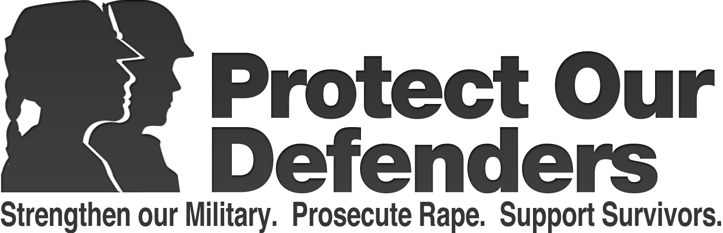

DRAFT
FOR IMMEDIATE RELEASE
May 29, 2013 Contact: Brian Purchia, 202-253-4330, brian@protectourdefenders.com
*** PRESS RELEASE ***
PROTECT OUR DEFENDERS FILES AMICUS BRIEF IN SUPPORT OF AIR FORCE SPECIAL VICTIMS COUNSEL PROGRAM; CALLS ON PRESIDENT OBAMA AND SEC. HAGEL TO SUPPORT SEXUAL ASSAULT VICTIMS RIGHTS TO AN ATTORNEY
Air Force courts deny victims of sexual assault representation to protect their privacy rights; Air Force’s Special Victims Counsel Program that offers new hope to victims under attack
Washington DC – In recent weeks, Americans have watched in horror as new military sexual abuse scandals have broken almost daily. New reports from the Pentagon show the epidemic is getting worse and victims say they are more afraid then ever to come forward. In response, President Obama has called the epidemic an “outrage” and told victims that he has their “backs.” However, military sexual assault victims’ basic rights are under attack. Two Air Force courts, a trial court and an appellate court, have refused to allow a sexual assault victim’s appointed attorney to represent her in court as she tries to protect her privacy. On Tuesday, Protect Our Defenders filed an amicus brief in support of the victim in the United States Court of Appeals for the Armed Forces (“CAAF”).
“Victims of military sexual trauma do not deserve to be victimized again by a broken military justice system. Congress, the President, and the Department of Defense each have the power to fix this tragic situation,” said Nancy Parrish, President of Protect Our Defenders. “President Obama and Secretary Hagel should act now and show that they have victims’ backs by protecting and strengthening the Air Force’s Special Victim Counsel Program. Every day this epidemic of military sexual assault grows, victims are being abused and re-victimized by the broken military justice system. This must be stopped.”
A portion of the Amicus Brief filed today by Protect Our Defenders is below, for the full text, please click here (PDF download).
Victims do not report rapes and assaults because they lack faith in and fear the military justice system and their chain of command. Although victims hear the President, Secretary of Defense and other senior leadership announce the zero tolerance policy, they see a commander dismiss - make disappear - sexual assault convictions. They see a field grade officer responsible for preventing and responding to sexual assault be arrested for sexually assaulting a woman. They see a unit sexual assault response coordinator arrested for pandering. They see a general officer on trial for sexual assault creating a website to attack the victim. They see a Lt. General overturn the sexual assault conviction of a fellow pilot, a Lt. Colonel. They see scandal after scandal.
Sexual assault victims are not blind. They are not dumb.
Congress adopted the military rape shield rule to protect victims’ privacy; however, this protection is useless if the victim cannot enforce it. Victims see defense counsel use their sexual history as leverage to undermine their credibility, to intimidate them, to humiliate them, and to ultimately dissuade them from proceeding with the case. The military justice system leaves victims feeling exposed and naked. Only 18% of women who reported sexual assault to the DoD would make the same decision to report if they could do it over. It is fundamentally unfair to repeatedly expose the victim to attacks by skilled defense counsel when she is unrepresented and powerless to defend herself. [Full Text of the Amicus Brief]
In the wake of the ongoing sexual abuse scandal at Lackland Air Force Base, the Air Force recently took a strong step to shield victims from a harsh military justice system by creating a pilot project, the Special Victim Counsel (“SVC”) program. This program assigns an attorney to represent victims of sexual assault. The SVC program has offered new hope to victims -- and it currently stands alone in allowing military victims’ access to their own legal counsel. After less than three months, the Air Force program has represented over 260 victims.
Unfortunately, Air Force military judge, LTC Joshua Kastenberg, recently ruled that a victim of sexual assault does not have the right to be represented in court by legal counsel. LTC Kastenberg ruled that victims couldn’t be represented by an attorney in order to oppose intrusions into their sexual behavior and mental health records. The military’s rules of evidence restrict these intrusions, and specifically provide the victim with the right to be heard. A right with no remedy is no right and congress must act to clarify the law.
On appeal to the Air Force Court of Criminal Appeals (“AFCCA”), the court refused to even consider whether LTC Kastenberg’s ruling was correct because the court held that it had no power, or jurisdiction, to hear the victim’s appeal. Protect Our Defenders cannot find any appellate court that has ruled that it had no jurisdiction to hear an appeal concerning its own rules of evidence.
The victim has appealed the AFCCA’s decision to the CAAF. Protect Our Defenders’ amicus brief explains:
- why the AFCCA and CAAF have the power to review LTC Kastenberg’s ruling;
- that representation of victims by their own attorneys is ordinary and common throughout the federal and state criminal justice systems; and
- military sexual assault victims’ perspective of the military justice system.
Victims need legal counsel to protect their privacy rights concerning their sexual history and mental health records. Judge Kastenberg’s ruling completely eviscerates the SVC program and once again leaves victims alone and unprotected.
“As a first step, this issue needs clear and decisive leadership from our Secretary of Defense. The military must stop fighting with itself over whether or not victims have the right to due process and privacy,” said Parrish.
---
*A copy of Air Force LTC Joshua Kastenberg’s US v. Daniels, USAF decision and other cases mentioned are available for download, by clicking here:
http://protectourdefenders.com/downloads/AFFCA_filings.zip
Air Force to provide dedicated legal counsel to sexual assault victims
http://www.af.mil/news/story.asp?id=123331538
TIME: The Nightmare Continues
http://nation.time.com/2013/05/21/the-nightmare-continues/?xid=rss-topstories
San Antonio Express-News: Twice Betrayed
http://www.mysanantonio.com/twice-betrayed/
Bloomberg: Obama Vows Action After Air Force Sex-Assault Chief Charged http://www.sfgate.com/business/bloomberg/article/Obama-Vows-Action-After-Air-Force-Sex-Assault-4495939.php#ixzz2SezqWPEB
Wired Magazine: Air Force’s Accountability for Sexual Assault: Not Promoting Convicted Officer
http://www.wired.com/dangerroom/2013/03/air-force-assault/
NBC News: Civil Rights Commission urged to order audit of military sex-assault cases
http://usnews.nbcnews.com/_news/2013/01/11/16469177-civil-rights-commission-urged-to-order-audit-of-military-sex-assault-cases?lite
About Protect Our Defenders: Protect Our Defenders is a human rights organization. We seek to honor, support and give voice to the brave women and men in uniform who have been sexually assaulted while serving their country, and re-victimized by the military adjudication system – a system that often blames the victim and fails to prosecute the perpetrator. Learn more about Protect Our Defenders at www.protectourdefenders.com or on Facebook at http://facebook.com/ProtectOurDefenders or follow us on Twitter at https://twitter.com/ProtectRDfnders.
Protect Our Defenders partners with Attorney Susan Burke, Burke PLLC to advance lawsuits filed against the DoD and service academies for repeatedly ignoring rape, sexual assault and harassment, failing to prosecute perpetrators and retaliating against the victim.
###

